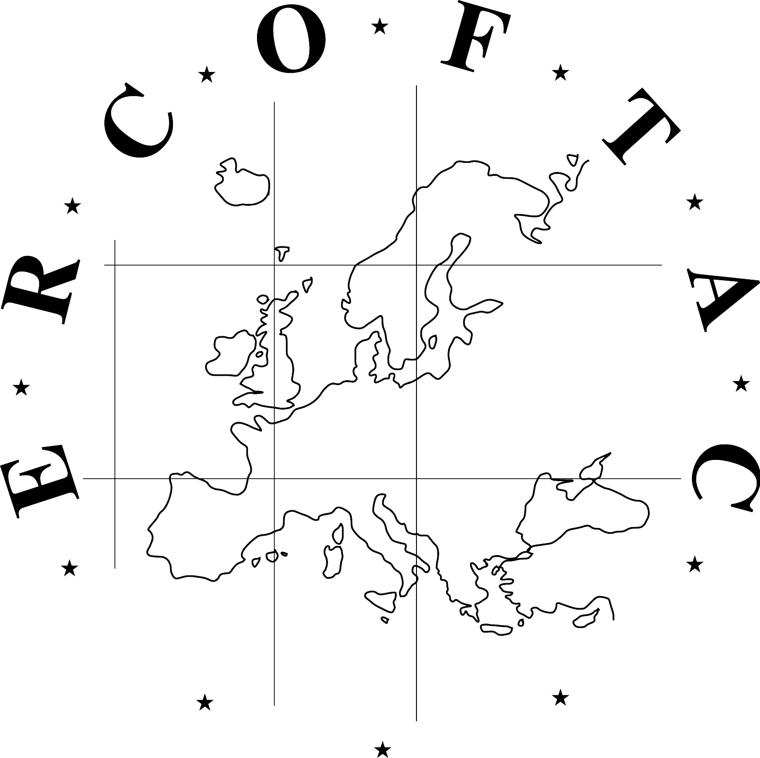
ERCOFTAC Spring Festival
European Research Community On Flow, Turbulence And Combustion
15-16 April 2019
Von Karman Institute, Brussels

If you wish to attend ERCOFTAC Spring Festival 2019 please this complete registration form and send it to email address: admin@cado-ercoftac.org before 30th March 2019 indicating as subject: “ERCOFTAC Autumn Festival 2019 Registration”. Thank you.

1 – Personal details

LAST NAME (in capitals):

First name:
Title: Prof Dr Mr Ms Student Other

Position:
Organization:

Business Address:
City: Warsaw State:

E-mail:

2- Details for organisation for ERCOFTAC Spring Festival 2019

Arrival date in Brussels: -

Departure date: -

You attend to participate:

Monday, April 15th:
- Registration for Scientific Day YES NO
- Lunch* YES NO
- ERCOFTAC Dinner* in a restaurant YES NO

Tuesday, April 16th:
- ERCOFTAC meetings YES NO
- Lunch* YES NO

* Please indicate if special diet is required:

