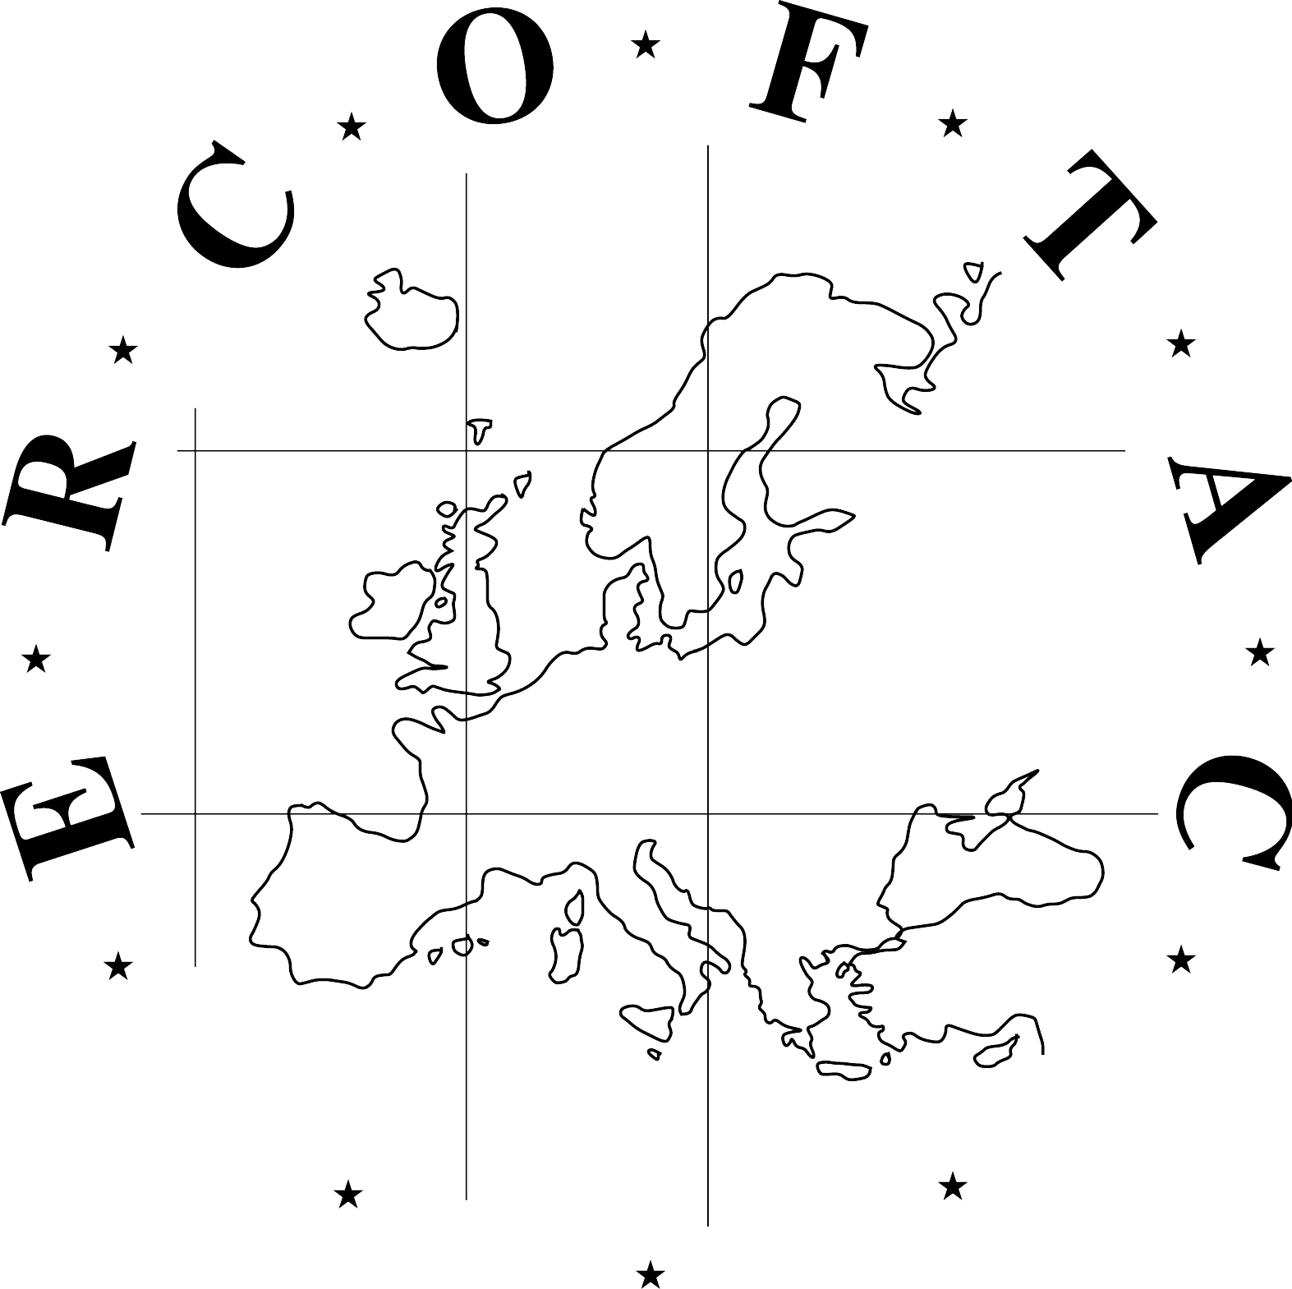
ERCOFTAC Autumn Festival
European Research Community On Flow, Turbulence And Combustion
Da Vinci Competition
18 -19 October 2018,
Warsaw University of Technology, Warsaw, Poland

If you wish to attend ERCOFTAC Autumn Festival 2018 please this complete registration form and send it to email address: admin@cado-ercoftac.org before 30th September 2018 indicating as subject: “ERCOFTAC Autumn Festival 2018 Registration”. Thank you.

1 – Personal details

LAST NAME (in capitals):

First name:
Title: Prof Dr Mr Ms Student Other

Position:
Organization:

Business Address:
City: State:
Post/Zip code: Country:

E-mail:

2- Details for organisation for ERCOFTAC Autumn Festival 2018

Arrival date in Warsaw:

Departure date:

You attend to participate:

Thursday, October 18th:
- Registration for Scientific Day YES NO
- Lunch* YES NO
- ERCOFTAC Dinner* in a restaurant YES NO

Friday, October 19th:
- ERCOFTAC meetings YES NO
- Lunch* YES NO

* Please indicate if special diet is required:

